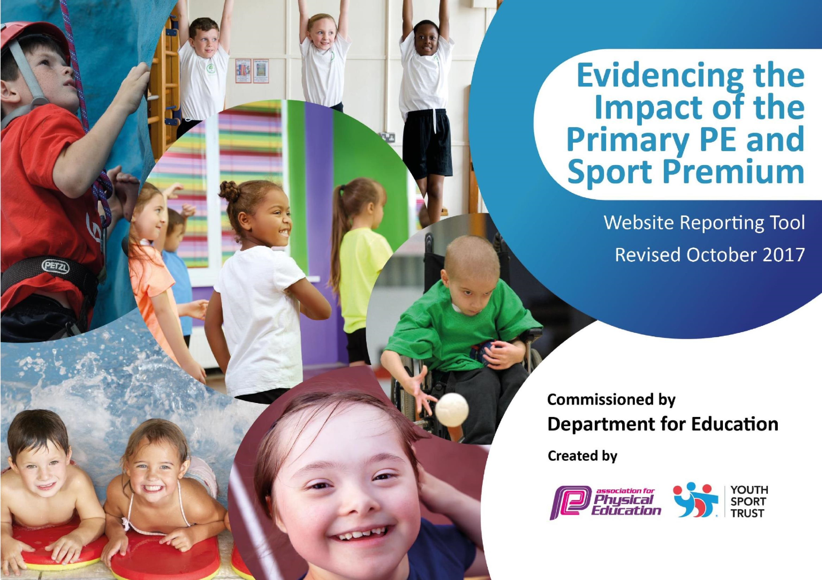
Schools must use the funding to make additional and sustainable improvements to the quality of PE and sport they offer. This means that you should use the Primary PE and Sport Premium to:

• •

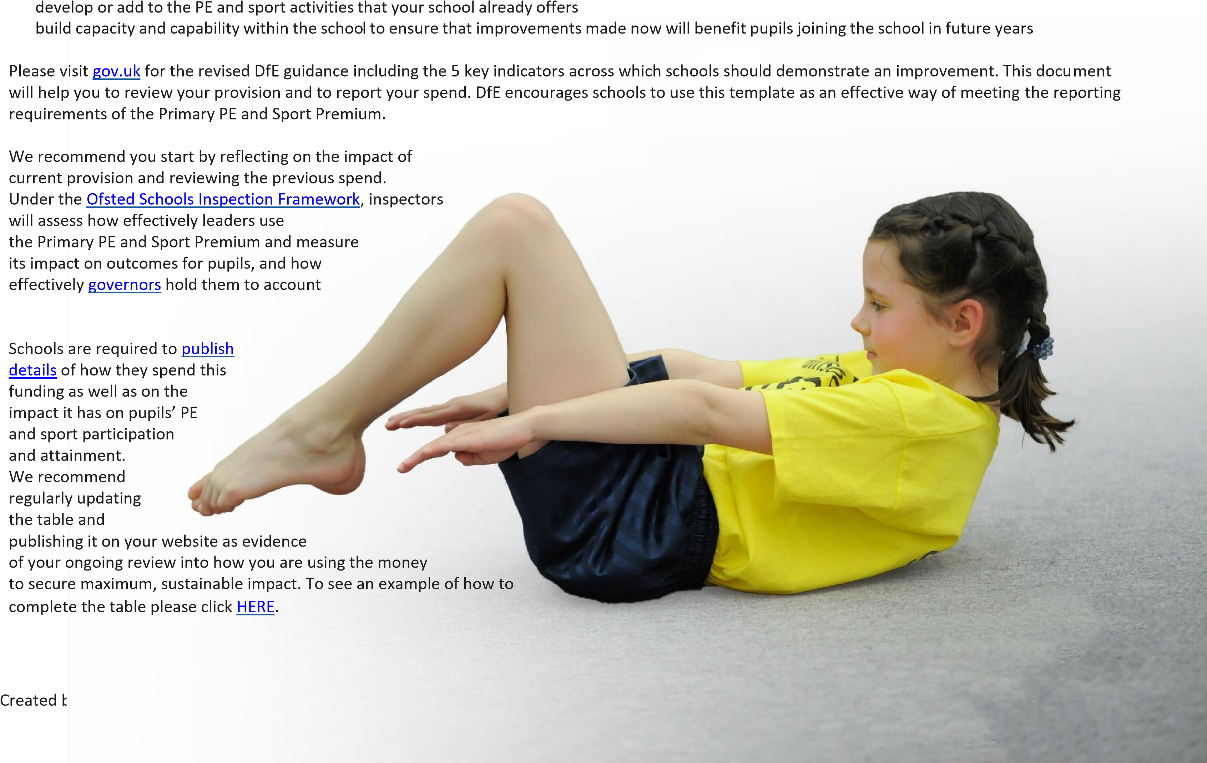
for this.

Support for review and reflection - considering the 5 key indicators from DfE, what development needs are a priority for your setting and your students now and why? Use the space below to reflect on previous spend, identify current need and priorities for the future.

Key achievements to date: | Areas for further improvement and baseline evidence of need:
- The school offer for extra-curricular sporting activities in 2020/21 was included boxing.  - Staff have received professional development from coaches who have delivered P.E. sessions – Tennis, Boxing, Cricket and Rugby  - All classes have taken part in the Daily Mile using a range of resources to support them (scooters, pre-pedal bikes etc)  - The school has invested heavily in resources for PE sessions so that children can experience a range of different sports.  - Our Rainbow Room children won East Yorkshire Primary Winter Games Panathlon 20/21 and were also Panathlon Winter Kurling Champions 20/21  - Our KS2 Year 3 boys and girls, Year 6 boys, Year 4 girls Cross Country teams got through the finals (Level 3) but unfortunately it was cancelled due to Covid.  - Whole school participation in the Hull Active Schools Virtual Competitions including 3 Peaks Challenge, Wolds Way Challenge and the Hull Marathon.  - Year 5 successfully completed their Bikeability, with all children achieving at least Level 1.  - Year 5 completed the Race For Life. |  | • | Increase the potential of physical activity in EYFS. (On entering the school in Nursery and Reception, the data suggests gaps in pupil’s gross and fine motor skills. A lack of access to a range of different types of physical activity in the outdoor area is affecting the school’s ability to close the gap at a rapid rate.) This is rolled over from last year. Due to Covid, the area did not get completed. It will be completed by March 2021.  Increase in targeted physical activity during school break times. (Currently, there is little to keep pupils engaged during break times and often children will simply sit on benches and not engage in any physical activity. We want pupils to exert energy during break times which we believe will support both their physical and mental well-being.)  Ensure ALL pupils meet the requirements of the swimming curriculum by the time they leave the school. (There is still a small percentage of pupils who do not meet the national curriculum requirements for swimming. We prioritise this as a life skill, and therefore want all pupils to achieve this minimum standard.)  Continue to offer experiences to pupils in a wide range of sports. (Many pupils will not get the opportunity to experience different sports in the local community. We want to capture pupils’ interest in the types of sports available to them and signpost them to external clubs that offer these.)
•
•
•

Meeting national curriculum requirements for swimming and water safety | Please complete all of the below:

What percentage of your Year 6 pupils could swim competently, confidently and proficiently over a distance of at least 25metres when they left your primary school at the end of last academic year? | 100%

Created by: Supported by:

What percentage of your Year 6 pupils could use a range of strokes effectively [for example, front crawl, backstroke and breaststroke] when they left your primary school at the end of last academic year? | 100%
What percentage of your Year 6 pupils could perform safe self-rescue in different water-based situations when they left your primary school at the end of last academic year? | 100%
Schools can choose to use the Primary PE and Sport Premium to provide additional provision for swimming but this must be for activity over and above the national curriculum requirements. Have you used it in this way? | No

Action Plan and Budget Tracking
Capture your intended annual spend against the 5 key indicators. Clarify the success criteria and evidence of impact that you intend to measure to evaluate for students today and for the future.

Academic Year: 2020/21 |  | Total fund allocated: £) 14 479 |  |  | Date Updated: 22/07/21
Key indicator 1: The engagement of all pupils in regular physical activity – Chief Medical Officer guidelines recommend that primary school children undertake at least 30 minutes of physical activity a day in school |  |  |  |  |  | Percentage of total allocation:
 |  |  |  |  |  | 24%
School focus with clarity on intended impact on pupils: |  | Actions to achieve: |  | Funding allocated: | Evidence and impact: | Sustainability and suggested next steps:
- Increase pupil participation in physical activity within and beyond the curriculum offer. |  | - Engage more pupils in physical activity during break times using equipment recently purchased. |  | £1000 | £3,424.70  Due to children staying in bubbles and unable to compete in intra competitions, more money was used to improve our equipment to enable all children throughout the school to use it during a physical activity.  EYFS outdoor physical activity tations are now complete. | Equipment has led to children working collaboratley and has had a great physical impact.  To introduce more variety of equipment to engage all children in KS1 and KS2
Key indicator 2: The profile of PE and sport being raised across the school as a tool for whole school improvement |  |  |  |  |  | Percentage of total allocation:
 |  |  |  |  |  | 4%
School focus with clarity on intended impact on pupils: |  | Actions to achieve: |  | Funding allocated: | Evidence and impact: | Sustainability and suggested next steps:
-  -  - | Enhance pupil interest in, and leadership of, sporting activities.  Reward pupils who involve themselves in sporting activity beyond the curriculum offer.  Celebrate pupil’s motivation through a ‘Sports Personality | -  -  - | Train and equip x6 Sports Ambassadors.  Purchase medals, trophies, certificates etc.  Purchase trophy, medals, tea/coffee for parents | £150  £500  £400 | £577.32  Sports Leaders have trained through Zoom and led warm ups/cool downs/ small group sessions during their own PE lessons.  Medals for the whole school for participating in Sports Day  Trophies for the Sports Leaders for their Leavers Award Ceremony  Badges/kit for the Sports Leaders to show who they are | To continue next year with 3 Leaders who will lead lunch time clubs and assist at competitions

of the Year’ event. | attending

Key indicator 3: Increased confidence, knowledge and skills of all staff in teaching PE and sport |  |  |  | Percentage of total allocation:
 |  |  |  | 2%
School focus with clarity on intended impact on pupils: | Actions to achieve: | Funding allocated: | Evidence and impact: | Sustainability and suggested next steps:
- Staff to receive ongoing CPD by shadowing high-quality expert coaches in a range of sports.  - PE Kit for all staff who deliver  PE lessons | Staff ‘up-skilled’ in a range of sports so that delivery in future years is of a high quality.  To encourage and show pupils that an appropriate kit must be worn for PE | NA – built within the broader range allocation  £1000 | £277.00  New PE T shirts for all staff. This shows the children that the staff are ready for their lesson and are appropriately dressed in school colours | Research cost of tracksuits for the staff for Aut/Winter PE sessions
Key indicator 4: Broader experience of a range of sports and activities offered to all pupils |  |  |  | Percentage of total allocation:
 |  |  |  | 24%
School focus with clarity on intended impact on pupils: | Actions to achieve: | Funding allocated: | Evidence and impact: | Sustainability and suggested next steps:
- Continue to offer a wide range of sports both within and beyond the curriculum in order to get more pupils involved.  - Enable pupils with SEND to access a range of physical activities.  - Ensure all pupils become competent swimmers by the time they leave school.  - Enable pupils in EYFS and KS1 to participate in a range of broader activities and sports | - Coaches for boxing, cricket, rugby and tennis,  - Continue to offer ‘adapted cycling’ as a wider experience.  - For those pupils who do not pass swimming in Y4, vouchers to be provided for additional swimming sessions.  - Visits to organised sites to participate in orienteering and other sporting events | £3555  £300  £300  £1000 | £1880. Classes from Year 1-6 have had the opportunity to be coached this year. During this coaching our staff have received CPD. | To carry forward to September due to Covid  To carry forward to September due to Covid  To carry forward to September due to Covid
Key indicator 5: Increased participation in competitive sport |  |  |  | Percentage of total allocation:
 |  |  |  | 46%

School focus with clarity on intended impact on pupils: |  | Actions to achieve: |  | Funding allocated: | Evidence and impact: | Sustainability and suggested next steps:
-  - | Continue to offer pupils the opportunity to take part in a range of intra/inter-school competitions.  Continue to increase the percentage of KS1 pupils taking part in competitive  activities | -  -  -  - | Membership of HAS to access competitions. Absolute Coaching  Trust-wide/Cluster events which focus on KS1 competitions.  Continue to lease mini-bus to reduce transportation costs and enable more children to access competitions. | £1500  £375  NA  £2500 | £600  £395  £5710 | Due to Covid, all our competitions this year have been virtual.  Even though we have not been able to use the bus except for residential, we have had too continue to pay the lease

