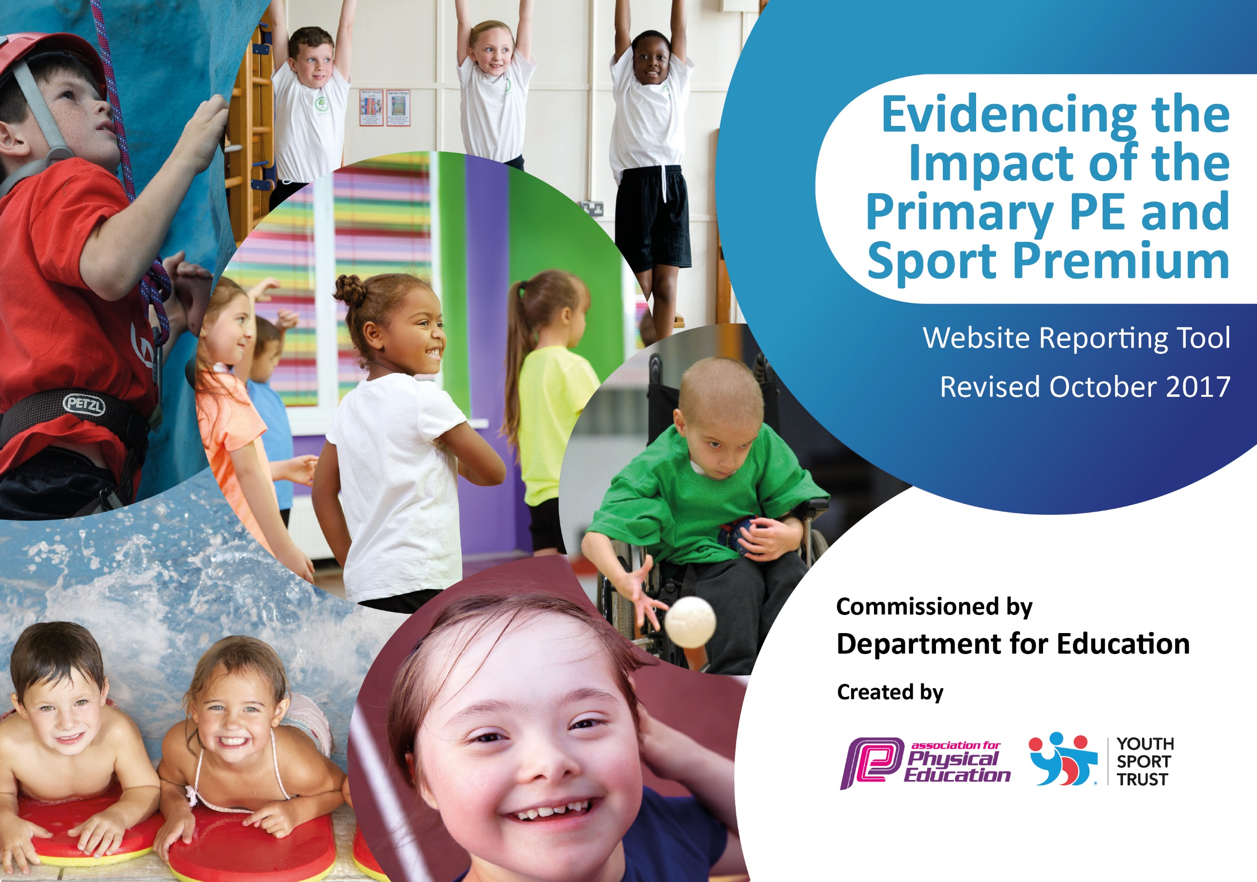

Schools must use the funding to make additional and sustainable improvements to the quality of PE and sport they offer. This means that you should use the Primary PE and Sport Premium to:

- develop or add to the PE and sport activities that your school already offers
- build capacity and capability within the school to ensure that improvements made now will benefit pupils joining the school in future years

Please visit gov.uk for the revised DfE guidance including the 5 key indicators across which schools should demonstrate an improvement. This document will help you to review your provision and to report your spend. DfE encourages schools to use this template as an effective way of meeting the reporting requirements of the Primary PE and Sport Premium.

We recommend you start by reflecting on the impact of current provision and reviewing the previous spend.
Under the Ofsted Schools Inspection Framework, inspectors will assess how effectively leaders use
the Primary PE and Sport Premium and measure its impact on outcomes for pupils, and how effectively governors hold them to account
for this.

Schools are required to publish details of how they spend this funding as well as on the impact it has on pupils’ PE
and sport participation and attainment.
We recommend regularly updating the table and
publishing it on your website as evidence
of your ongoing review into how you are using the money
to secure maximum, sustainable impact. To see an example of how to complete the table please click HERE.

Support for review and reflection - considering the 5 key indicators from DfE, what development needs are a priority for your setting and your students now and why? Use the space below to reflect on previous spend, identify current need and priorities for the future.

Key achievements to date: | Areas for further improvement and baseline evidence of need:
- The school has been awarded the ‘School Games Gold Award’ for the fourth consecutive year.  - 100% of pupils in Key Stage 1 and 2 took part in at least one intra and inter-school competition in 2017/18.  - 4 teams from the school represented the school at the level 3 County Championships in tri-golf, table-tennis, orienteering and cross-country.  - The school won the Year 6 orienteering at county level.  - The school offer a wider range of activities in 2017/18 including badminton and boxing.  - 26 pupils from Y6 achieved their gold award in boxing.  - Staff have received professional development from coaches who have delivered P.E. sessions. | - Reception to be included in intra-school competitions (last academic year, none of our reception pupils took part in competitions, whereas all other pupils across the school did).  - Key Stage 1 to be exposed to expert coaching in a wider range of sporting activities (Key Stage 2 have historically received lots of expert coaching in a range of sports, whereas KS1 has been limited).  - Ensure all pupils by the end of KS2 can swim the expected distance and strokes (this year, two pupils did not pass their swimming).  - To continue to invest in new sporting equipment (we want to increase our pupil’s exposure to different sports and want to give them the correct equipment and resources to enable them to enjoy new sports).  - To introduce ‘The Daily Mile’ (we want our children to be involved in more physical activity than what is expected)

Meeting national curriculum requirements for swimming and water safety | Please complete all of the below:
What percentage of your Year 6 pupils could swim competently, confidently and proficiently over a distance of at least 25metres when they left your primary school at the end of last academic year? | 97%
What percentage of your Year 6 pupils could use a range of strokes effectively [for example, front crawl, backstroke and breaststroke] when they left your primary school at the end of last academic year? | 97%
What percentage of your Year 6 pupils could perform safe self-rescue in different water-based situations when they left your primary school at the end of last academic year? | 97%
Schools can choose to use the Primary PE and Sport Premium to provide additional provision for swimming but this must be for activity over and above the national curriculum requirements. Have you used it in this way? | No

Action Plan and Budget Tracking
Capture your intended annual spend against the 5 key indicators. Clarify the success criteria and evidence of impact that you intend to measure to evaluate for students today and for the future.

Academic Year: 2018/19 | Total fund allocated: £22294 (inc £6294 carryover) |  | Date Updated: 26/09/2018
Key indicator 1: The engagement of all pupils in regular physical activity – Chief Medical Officer guidelines recommend that primary school children undertake at least 30 minutes of physical activity a day in school |  |  |  |  | Percentage of total allocation:
 |  |  |  |  | 26.9%
School focus with clarity on intended impact on pupils: | Actions to achieve: | Funding allocated: |  | Evidence and impact: | Sustainability and suggested next steps:
- Increased participation in physical activity at lunchtimes  - Increase the sporting offer to pupils within the school  - Overall increased participation in physical activity | - Employ a play leader for 1 hour per day to engage pupils in sports during lunchtime.  - Invest in a wider range of sporting equipment  - Create a ‘track’ on the playground to complete The Daily Mile  - Invest in different modes of transportation to engage those that are reluctant to run | £2000  £2000  £2000
Key indicator 2: The profile of PE and sport being raised across the school as a tool for whole school improvement |  |  |  |  | Percentage of total allocation:
 |  |  |  |  | 7.8%
School focus with clarity on intended impact on pupils: | Actions to achieve: | Funding allocated: |  | Evidence and impact: | Sustainability and suggested next steps:
- Provide opportunities for pupils to take more ownership of leading sporting activities within the school.  - Enable all pupils to take part in physical activity all-year-round.  - Reward pupils who represent the school at sporting competitions. | - Train and equip x5 sports ambassadors.  - Purchase outdoor clothing as a ‘pool’ to enable all pupils (including those who persistently forget their P.E. kit) to take part in sporting activities.  - Purchase medals, trophies and certificates. | £150  £1000  £600

Key indicator 3: Increased confidence, knowledge and skills of all staff in teaching PE and sport |  |  |  | Percentage of total allocation:
School focus with clarity on intended  impact on pupils: | Actions to achieve: | Funding  allocated: | Evidence and impact: | Sustainability and suggested  next steps:
- Staff to receive ongoing CPD by shadowing high-quality expert coaches in a range of sports. | - Staff will be ‘up-skilled’ in each of the sporting areas so that they can teach these in future years.
Key indicator 4: Broader experience of a range of sports and activities offered to all pupils |  |  |  | Percentage of total allocation:
 |  |  |  | 32.7%
School focus with clarity on intended  impact on pupils: | Actions to achieve: | Funding  allocated: | Evidence and impact: | Sustainability and suggested  next steps:
- Continue to offer a wide range of sports both within and beyond the curriculum in order to get more pupils involved.  - Identify pupils who are gifted and talented within a sport and offer further opportunities.  - Increased provision for pupils with physical disabilities. | - Coaches for table-tennis, badminton, boxing, football, tennis, cricket, Go-Skoot and pre-pedal  - Offer additional extra-curricular activities for pupils identified as G&T in different sports, enabling local coaches to recruit our pupils.  - Offer ‘adapted cycling’ so that all pupils can ride cycles. | £6000  £1000  £300
Key indicator 5: Increased participation in competitive sport |  |  |  | Percentage of total allocation:
 |  |  |  | 42.6%
School focus with clarity on intended  impact on pupils: | Actions to achieve: | Funding  allocated: | Evidence and impact: | Sustainability and suggested  next steps:
- Continue to offer pupils the opportunity to take part in competitions.  - Increase the range of competitions that pupils can take part in.  - Increase the opportunity for KS1 pupils to take part in competitive sports. | - Join HAS in order to access local competitions.  - Work with Yorkshire Schools Dance Festival to broaden pupil’s experience.  - Increase pupil participation in local inter-school competitions.  - Invest in leasing a mini-bus to transport pupils to and from sporting competitions. | £1500  £1000  £5600

