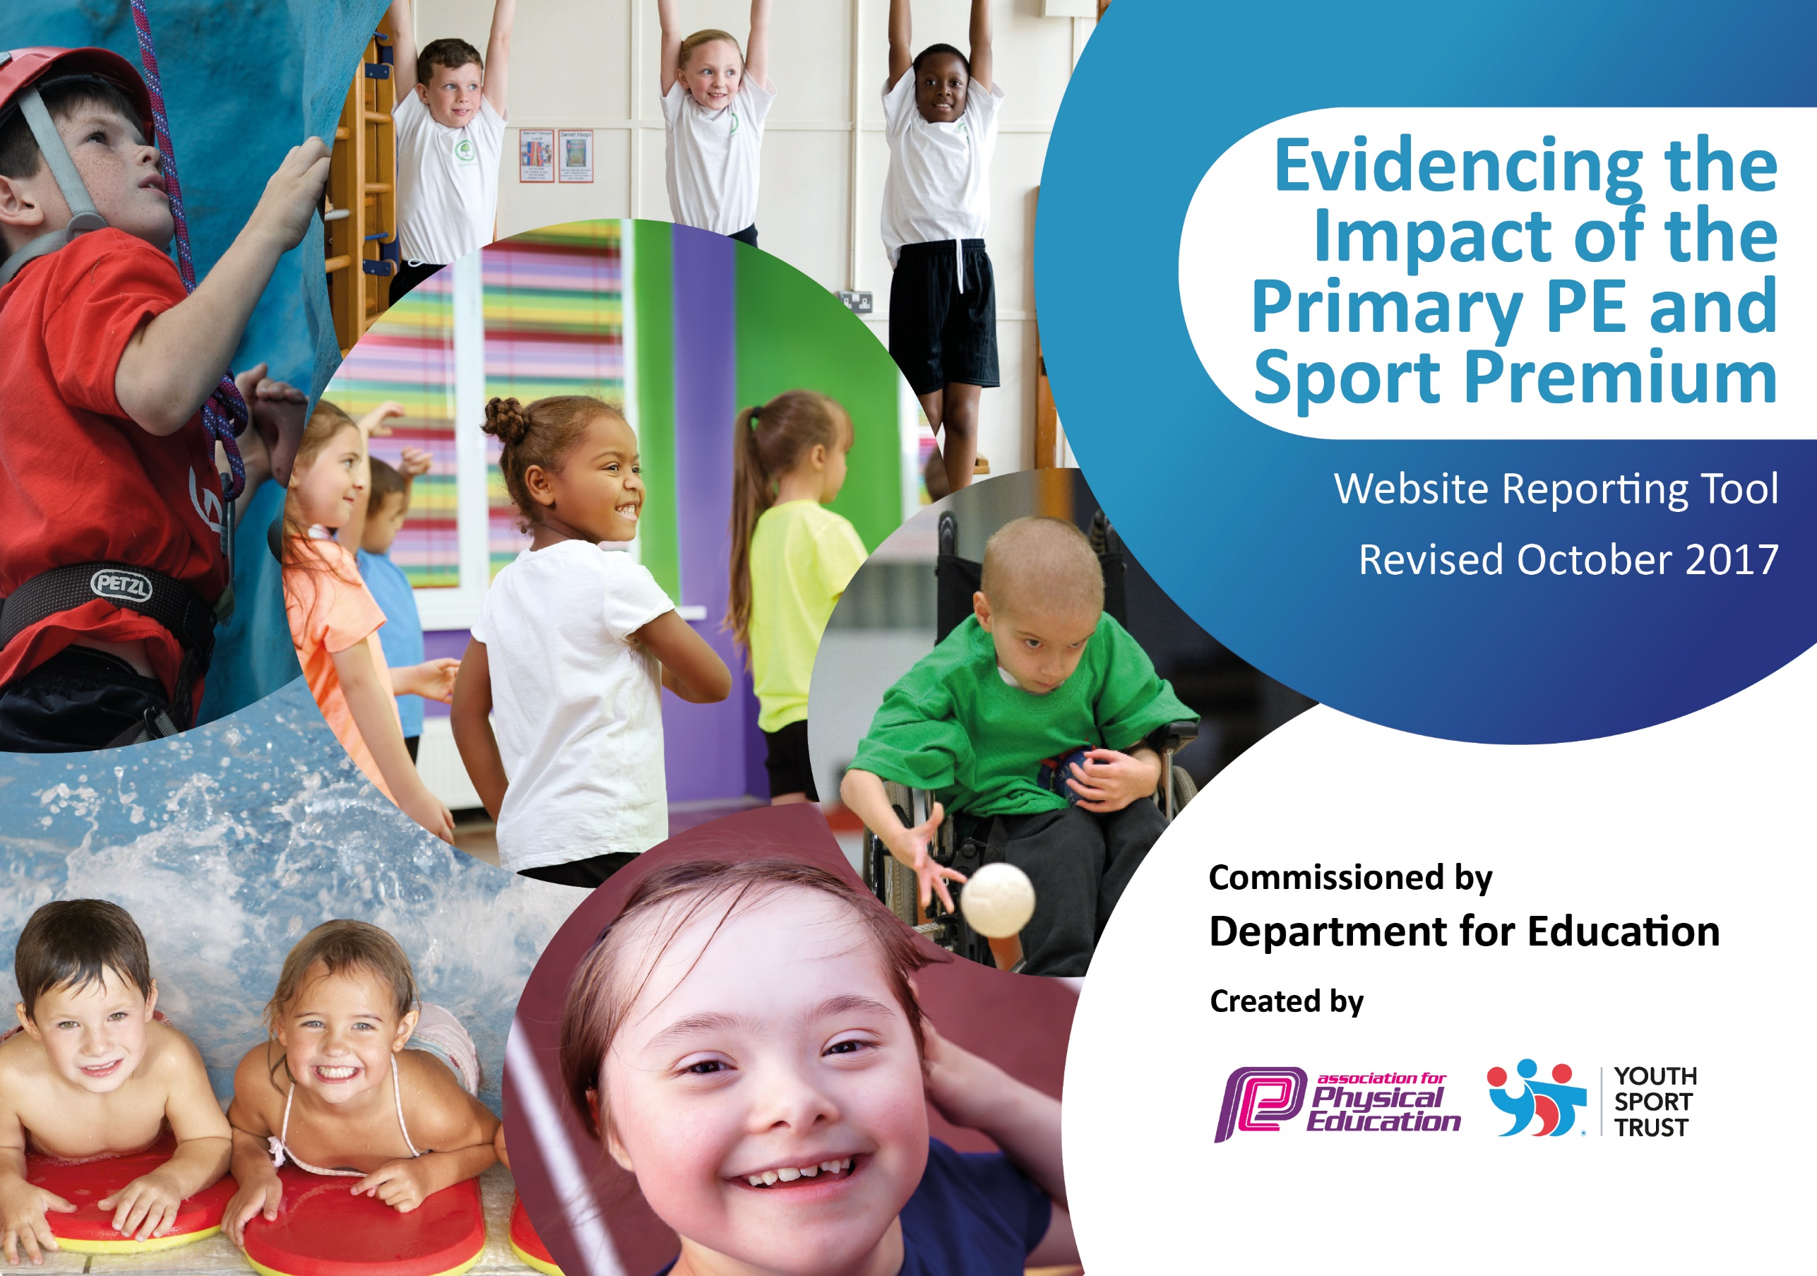

Schools must use the funding to make additional and sustainable improvements to the quality of PE and sport they offer. This means that you should use the Primary PE and Sport Premium to:

- develop or add to the PE and sport activities that your school already offers
- build capacity and capability within the school to ensure that improvements made now will benefit pupils joining the school in future years

Please visit gov.uk for the revised DfE guidance including the 5 key indicators across which schools should demonstrate an improvement. This document will help you to review your provision and to report your spend. DfE encourages schools to use this template as an effective way of meeting the reporting requirements of the Primary PE and Sport Premium.

We recommend you start by reflecting on the impact of current provision and reviewing the previous spend.
Under the Ofsted Schools Inspection Framework, inspectors will assess how effectively leaders use
the Primary PE and Sport Premium and measure its impact on outcomes for pupils, and how effectively governors hold them to account
for this.

Schools are required to publish details of how they spend this funding as well as on the impact it has on pupils’ PE
and sport participation and attainment.
We recommend regularly updating the table and
publishing it on your website as evidence
of your ongoing review into how you are using the money
to secure maximum, sustainable impact. To see an example of how to complete the table please click HERE.

Support for review and reflection - considering the 5 key indicators from DfE, what development needs are a priority for your setting and your students now and why? Use the space below to reflect on previous spend, identify current need and priorities for the future.

Key achievements to date: | Areas for further improvement and baseline evidence of need:
- The school has been awarded the ‘School Games Gold Award’ for three consecutive years.  - 80% of pupils at the school took part in at least one intra and inter-school competition in 2016/17.  - 4 teams from the school represented the school at the level 3 County Championships in tri-golf, boccia, orienteering and cross-country.  - The school offers a wide range of extra-curricular sporting activities to engage all pupils.  - Staff have received coaching in new sports i.e. from expert gymnasts. | - Increase the percentage of KS2 pupils attending after school sporting clubs and taking part in intra and inter-school competitions.  - To provide opportunities for KS1 pupils to take part in intra and inter-school competitions. (Only 20% of KS1 pupils took part in competitions in 2016/17)  - To invest in new equipment that allows pupils to experience a wider range of sporting activities. (The school does not currently have access to equipment which will allow it to provide sports which children are requesting i.e. football goal posts, basketball hoops etc.)

Meeting national curriculum requirements for swimming and water safety | Please complete all of the below:
What percentage of your Year 6 pupils could swim competently, confidently and proficiently over a distance of at least 25metres when they left your primary school at the end of last academic year? | 95%
What percentage of your Year 6 pupils could use a range of strokes effectively [for example, front crawl, backstroke and breaststroke] when they left your primary school at the end of last academic year? | 95%
What percentage of your Year 6 pupils could perform safe self-rescue in different water-based situations when they left your primary school at the end of last academic year? | 95%
Schools can choose to use the Primary PE and Sport Premium to provide additional provision for swimming but this must be for activity over and above the national curriculum requirements. Have you used it in this way? | No

Action Plan and Budget Tracking
Capture your intended annual spend against the 5 key indicators. Clarify the success criteria and evidence of impact that you intend to measure to evaluate for students today and for the future.

Academic Year: 2017/18 | Total fund allocated: £17 760 | Date Updated: 07/11/2017
Key indicator 1: The engagement of all pupils in regular physical activity – Chief Medical Officer guidelines recommend that primary school children undertake at least 30 minutes of physical activity a day in school |  |  |  | Percentage of total allocation:
 |  |  |  | 28.2%
School focus with clarity on intended impact on pupils: | Actions to achieve: | Funding allocated: | Evidence and impact: | Sustainability and suggested next steps:
- Increase the sporting offer to pupils within the school.  - Increased participation in physical activity at lunchtimes. | - Invest in new sporting equipment to offer a wider range of sports.  - Employ a play leader for 1 hour per day to engage pupils in sports during lunchtime | £3000  £2000 | Summer 2018:  Football posts, basketball hoops, dodgeball equipment.  Awaiting the space to order more.  This additional allocation is currently being used for overtime costs for staff to accompany children on sporting costs. | £1412. Need to buy a container to store equipment so it can used more efficiently  Won a grant of £ 7500 From the National Lottery which has funded a play worker every lunch time until Christmas 2018.
Key indicator 2: The profile of PE and sport being raised across the school as a tool for whole school improvement |  |  |  | Percentage of total allocation:
 |  |  |  | 6.3%
School focus with clarity on intended impact on pupils: | Actions to achieve: | Funding allocated: | Evidence and impact: | Sustainability and suggested next steps:
- Provide opportunities for pupils to take on sports leaders roles.  - Enable all pupils to take part in outdoor physical education all year round.  - Reward pupils who represent the school at sporting competitions. | - Train and equip 4 sports ambassadors.  - Purchase rain jackets for outdoor P.E. sessions.  - Purchase medals, trophies and certificates. | £120  £500  £500 | Summer 2018  4 x Y6 trained – running lunchtime clubs.  Not done yet  Ordered. | £128 to equip Leaders with kit and resources to fulfill their role.  Not completed yet but £472 spent on kit for children to participate in competitions and represent the school  £561.50 for medals for the whole school for sports day and trophies for competitions and award winners in Year 6 leavers assembly

Key indicator 3: Increased confidence, knowledge and skills of all staff in teaching PE and sport |  |  |  | Percentage of total allocation:
 |  |  |  | 3.7%
School focus with clarity on intended  impact on pupils: | Actions to achieve: | Funding  allocated: | Evidence and impact: | Sustainability and suggested  next steps:
- Increase staff knowledge through team-teaching with external coaches. | - Buy in Hull KR Tag rugby  - Tigers Trust training for staff | £300  £350 | Summer Term 2018  Done in Autumn Term – Y3/4  N/A – the school have not been satisfied with the service offered by Tigers Trust this year and will therefore be ceasing from the end of this year. | £300  Completed CPD through lessons with the children
Key indicator 4: Broader experience of a range of sports and activities offered to all pupils |  |  |  | Percentage of total allocation:
 |  |  |  | 28.1%
School focus with clarity on intended  impact on pupils: | Actions to achieve: | Funding  allocated: | Evidence and impact: | Sustainability and suggested  next steps:
- Continue to offer a wide range of sports both within and beyond the curriculum in order to get more pupils involved.  - Identify pupils who are gifted and talented within a sport and offer further opportunities. | - Enroll with Tigers Trust for expert coaching and clubs offer.  - Increase the expert tuition for pupils at the school through the use of local external providers.  - Invest in additional expert tuition beyond the school and signpost to local clubs. | £4000  £990 | Summer Term 2018  Tigers Trust – football  Boxing, Badminton, Table-tennis, Cricket, go-skoot, pre-pedalling  Table-tennis, 3 Y6 attend L&S table tennis  3 x Y5 attend boxing clubs  12 x Y6 are currently in the process of going for their ‘Gold Award’ in boxing | £6251.50 this includes opportunities for our G&T children to further their participation in their specific sport and for our SEN children to have the opportunity to complete a 6 week course of Adapted cycling at East Park
Key indicator 5: Increased participation in competitive sport |  |  |  | Percentage of total allocation:
 |  |  |  | 33.8%
School focus with clarity on intended  impact on pupils: | Actions to achieve: | Funding  allocated: | Evidence and impact: | Sustainability and suggested  next steps:
- Continue to offer pupils the opportunity to take part in competitions.  - Increase the range of competitions that pupils can take part in.  - Increase the opportunity for KS1 pupils to take part in competitive sports. | - Join HAS in order to access all local competitions.  - Work with Yorkshire Schools Dance Festival to broaden pupil’s experience  - Provide transport to and from competitions free of charge through leasing a mini-bus | £1500  £1000  £3500 | Summer Term 2018  Performance in York in November.  Too-late to lease mini-bus.  This allocation is being spent on transport at no cost to pupils. | £1500  £1000  £2735 for coaches/minibuses to competitions  £325.00 Subscription to an online system for recording pupils participation in sporting activities - Absolute Coaching

